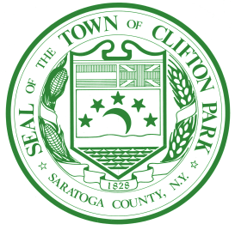
Town of Clifton Park
Highway Safety Committee

One Town Hall Plaza | Clifton Park, New York 12065 / FAX: (518) 371-1136

Traffic/Local Roadway Investigation Request

Please send completed forms to Clifton Park Highway Department via regular mail: One Town Hall Plaza, Clifton Park, NY 12065, by fax: 518-373-0039 or via e-mail to Dahn Bull, Highway Superintendent at dbull@cliftonpark.org.

Name: | Date:
Address: | Daytime Phone Number:
Location of Concern (Include nearest cross-street) | When Concerns Occurs (Time of Day/Direction)?
Further Explanation of Issue (If Necessary):

