Monday | Tuesday | Wednesday | Thursday | Friday
June 29   | June 30  Swim Testing  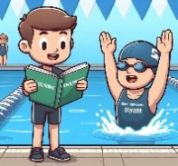 | July 1 | July 2  Swimming Day   | July 3  Pizza Lunch  
July 6   | July 7  Swim Testing | July 8  Field Trip  Eaglecrest Golf Course  1004 Route 146A | July 9  Swimming Day   | July 10  Pizza Lunch
July 13  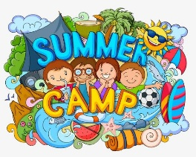 | July 14  Swim Testing | July 15  Field Trip  Skyzone & The Edge  22 Clifton Country Road | July 16    Swimming Day | July 17  Pizza Lunch
July 20   | July 21  Swim Testing | July 22  Stay Trip!  Utica Zoo Mobile  on site!! | July 23  Swimming Day   | July 24  Pizza Lunch
Art, Physical Education, and other specialty activities will be offered daily, with programming varying
based on scheduling, instructor availability, weather conditions, and other operational factors

Monday | Tuesday | Wednesday | Thursday | Friday
  July 27 | July 28  Swim Testing | July 29  Field Trip  Regal Movie Theater  22 Clifton Country Road | July 30  Swimming Day | July 31  Pizza Lunch
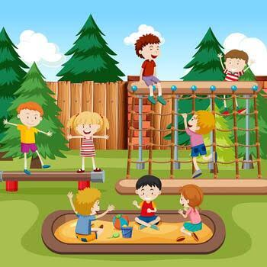  August 3 | August 4  Swim Testing | August 5  Field Trip  Ellms Farm  448 Charlton Rd, Ballston Spa, NY 12020 | August 6  Swimming Day | August 7  Pizza Lunch
  August 10 | August 11  Swim Testing | August 12  Field Trip  Lake George  Expedition Park  1912 US-9, Lake George | August 13  Swimming Day | August 14  Pizza Lunch
  August 17 | August 18  Swim Testing | August 19  Stay Trip!  Ice Skating  on-site!! | August 20  Swimming Day | August 21  Pizza Lunch
Art, Physical Education, and other specialty activities will be offered daily, with programming varying
based on scheduling, instructor availability, weather conditions, and other operational factors

